**Jason Yang**

**18322733**

**3/11/2020**

**Assignment:**

*To produce a short (2-4 page) biography of a key software engineer, discussing the work and impact of the individual (On the world and on myself personally).*

*“Write about a software Engineer that inspires you”*

**Bill Joy**

**Introduction:**

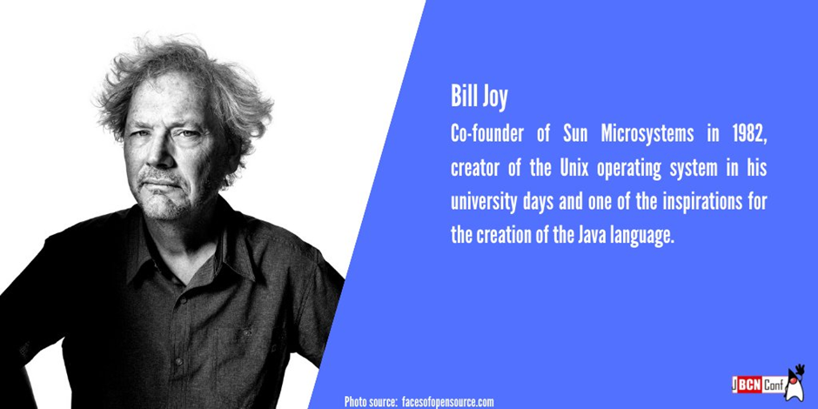

*"Take responsibility for the things you build and invent."* ~ Bill Joy

William Nelson Joy (born November 8, 1954) is an American computer engineer and venture capitalist. He co-founded Sun Microsystems in 1982 and served as Chief Scientist and CTO at the company until 2003. [1]

At its peak in 2006, Sun Microsystems employed 38,600 people. [2]  Sun is best known for its Unix systems, being the birthplace of Java, and having acquired MySQL AB in 2008 for US$1 billion. [3]

Sun Microsystems was acquired by Oracle Corporation for US$7.4 billion in 2009. The deal was completed on January 27, 2010.

As a software engineer, Bill Joy’s achievements are unparalleled. Joy wrote a version of UNIX that was so good it remains today.

*“If you put your computer in that funny mode where you can see the code, I see things that I remember typing in 25 years ago.” – Bill Joy in Malcolm Gladwell’s book ‘Outliers’ p40*

As well as this, Joy wrote much of the software that allows us to access the Internet today.

This is a short biography of Bill Joy describing his impact as a software engineer both on the world and as a source of inspiration for myself.

**Why Bill Joy:**

*“Bill Joy is one of the most influential people in the modern history of computing.” – David Gelernter, Yale Computer Scientist*

*Outliers* by Malcolm Gladwell is one of my all-time favourite books. In the book there is an entire chapter based around Bill Joy. I’ve always been meaning to research a little more about Bill Joy and this assignment happened to be the perfect opportunity.

Additionally, Joy is a particularly interesting and inspiring character for me personally for a number of reasons:

* In my personal experience the software engineer, entrepreneur, and venture capitalist is spoken about much less than other giants in the tech industry such as Bill Gates or Steve Jobs.
* He founded Sun Microsystems, a multi-billion-dollar tech company as well as a venture capital firm called HighBAR Ventures where he has already invested in several green energy industries. I admire how he uses his money to make a difference for our future.
* His concerns with genetic engineering and nanotechnology also resonate with me.

**Background:**

Joy was born in the Detroit suburb of Farmington Hills, Michigan, to William Joy, a school vice-principal and counsellor, and Ruth Joy. [5]

He went to the University of Michigan when he was sixteen and had been voted ‘most studious student’ by his graduating class at North Farmington High School outside Detroit. In 1975, he enrolled in graduate school at the University of California at Berkeley where he buried himself deeper into the world of computer software. [6]

During the oral exams for his PhD, he made up a particularly complicated algorithm on the fly that, as one of his many admirers has written, “so stunned his examiners that one of them later compared the experience to ‘Jesus confounding his elder.” [7]

Working in collaboration with a small group of programmers, Joy took on the task of rewriting UNIX, which was a software system developed b AT&T for mainframe computers. Joy’s version was so good it became and remains the operating system on which literally millions of computers around the world run. [8]

After graduating from Berkeley, Joy cofounded the Silicon Valley firm Sun Microsystems, which was one of the most critical players in the computer revolution. There he rewrote Java. [9]

**Sun Microsystems **

Joy was brought into Sun Microsystems as a co-founder after the firm had been going for 6 months. At sun, he was an inspiration for the development of the Network File System(NFS) which allows a user on a client computer to access files over a computer network[10], the Scalable Processor Architecture (SPARC) which is a reduced instruction set computing (RISC) instruction set architecture,[11] the Java programming language,[12] Jini/Apache River which is a network architecture for the construction of distribution systems in the form of modular co-operating services,[13] and Juxtapose (JXTA) which is an open-source peer-to-peer protocol specification. [14]

**Venture Capitalist**

Joy co-founded a venture capital firm called HighBar Ventures in 1999. In 2005 he was named a partner in the venture capital firm Kliener Perkins where he made several investments in green energy industries despite not having any credentials in the field. [15]

Joy considers himself a general hands-on investor whose method for investing is to ‘*look at something that seems like a good idea and assume it’s true.*’[16]

**Conclusion:**

Although Sun Microsystems has since been bought by Oracle Corporation and Bill Joy has transitioned into being a venture capitalist, his software remains.

Without his background as a software engineer and his massive contributions to Java and UNIX, we would not have our world’s most common programming language or such smooth computer operating systems.

Another notable contribution would be the ex and vi editors of the C shell.

Through his work, Bill Joy has enabled the next generation of software engineers, and this in my eyes is most impactful. His work is awe inspiring and motivating for the kind of work I’d like to do in the future.

**References:**

[1] <https://en.wikipedia.org/wiki/Bill_Joy>

[2]<https://web.archive.org/web/20060828042628/http://sun.com/aboutsun/company/facts.jsp>

[3] <https://en.wikipedia.org/wiki/Sun_Microsystems#cite_note-Sun_infopage-1>

[4] <https://web.archive.org/web/20100821093146/http://news.cnet.com/8301-30685_3-20000019-264.html>

[5] <https://en.wikipedia.org/wiki/Bill_Joy>

[6] [7] [8] [p39 Outliers – Malcolm Gladwell](https://en.wikipedia.org/wiki/Outliers_(book))

[9] [p40 Outliers – Malcolm Gladwell](https://en.wikipedia.org/wiki/Outliers_(book))

[10] <https://en.wikipedia.org/wiki/Network_File_System>

[11] <https://en.wikipedia.org/wiki/SPARC>

[12] <https://en.wikipedia.org/wiki/Java_(programming_language)>

[13] <https://en.wikipedia.org/wiki/Jini>

[14] <https://en.wikipedia.org/wiki/JXTA>

[15] <https://en.wikipedia.org/wiki/Bill_Joy>

[16] [Interview with NerdTV](https://www.youtube.com/watch?v=WpZEmpOwPkg&t=2197s)